**Exercises**

Exercise 1

Create and test an HTML document that describes nested ordered list of cars. The outer list must have three entries: compact , midsize, and sports. Inside each of these three lists there must be two sublists. The compact and midsize-car subtitles are two door and four door; the sports-car are coupe and convertible. Each body style sublist must have at least three entries, each of which is the make and model of a particular car that fits the category. The outer list must use uppercase Roman numerals, the middle list must use upper case letters, and their inner list must use Arabic numerals.

The background color for the compact-car list must be pink; for midsize-car list, it must be blue; for sports-car list, it must be red. All of the style must be in a document style sheet.

Exercise 2

(Use external level Style sheet)

Design a multiple webpages including html & CSS. Include all the CSS properties of text , border font etc. The following navigation tabs must be added:

1. Home ( Give info about what your website is about)
2. Product (Include the detailed information related to the particular product)
3. Contact (Include from to contact)
4. About

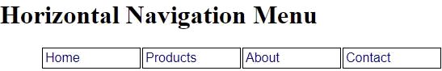

Exercise 3

Apply CSS to sign in and Login page. Using document level style sheet.

